Finite element analysis with AI

AgentFEM introductory exercises
Name ____________________ Date ____________________

Learning objectives
Describe a finite element problem, check modelling conditions and assess results using theory and numerical comparisons. No programming is required; identify the geometry, material, boundary conditions and quantities of interest.

Getting ready
Use an AI assistant connected to a local AgentFEM installation. First send:
Check whether you can run AgentFEM. Tell me its version and where projects will be saved. Ask for my approval before installing or configuring anything. For now, check the environment only; do not start a simulation.
Once available, send these instructions. Wait for the reply before sending an exercise.
I will send an exercise next. Once you receive it, create a new AgentFEM project, check and run it, and save the model and results. Show only one result figure, key values with units, and a two- or three-sentence explanation. Avoid lengthy analysis. Tell me if essential information is missing or you cannot run it. For now, reply only: ‘Ready. Please send the exercise.’ Do not start calculating or guess the exercise.

Procedure
1. Read the problem and predict the direction and magnitude of the response. Send the prompt, then check the figure, values and units.
2. Complete the comparison, fill in your observations and explain the results in your own words.
3. Check the reference answers on pages 8–10. If results differ substantially, check conditions before refining the mesh or time step.

Exercise guide
No. | Exercise | Check
1 | Cantilever deflection | Beam theory and load scaling
2 | Thick cylinder under internal pressure | Lamé solution
3 | Steady heat conduction in a plate | Linear temperature and Sixier’s law
4 | Transient heating of a plate | Analytical series and time-step comparison
5 | Column response under compression | Load curve and Euler load
6 | Re-entrant honeycomb | Solid plate comparison
Keep the model, a table of key values and a result figure for each exercise. Use consistent units and report results in the requested units.
Setup: see the installation guide in the references. Windows uses WSL2.

Exercise 1 Cantilever deflection
Distinguish true displacement from display magnification and check load–displacement proportionality.
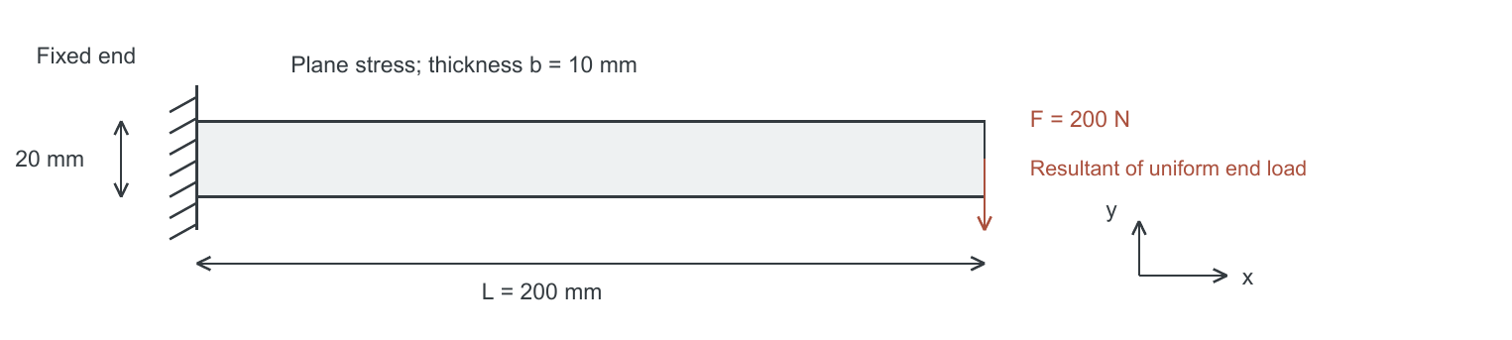

Problem conditions
Geometry | L = 200 mm; h = 20 mm; thickness b = 10 mm
Material | E = 210 GPa; ν = 0.30; homogeneous isotropic linear elasticity
Load and restraint | Left end fixed; total downward force 200 N uniformly distributed on the right end face
Assumptions | 2D plane stress; small displacements; no gravity

Modelling prompt
Use AgentFEM to analyse a steel cantilever beam: length 200 mm, height 20 mm, thickness 10 mm, Young’s modulus 210 GPa and Poisson’s ratio 0.3. Fix the left end and distribute a total downward force of 200 N uniformly over the right end face. Use a 2D plane-stress, small-displacement linear-elastic model and neglect gravity. Show the deformed shape and the downward displacement at the midpoint of the right end (mm). State the deformation scale factor on the figure.

Tasks
1. Record the downward displacement at the right-end midpoint and check its direction.
2. Repeat at 400 N with all other conditions unchanged. Calculate the deflection ratio.
3. Compare with cantilever beam theory and discuss possible sources of discrepancy.

Comparison prompt
Increase the total force to 400 N, keep everything else unchanged and run again. Compare the two tip deflections and their ratio. Explain the result using beam theory.
Submit the deformed shape, a load–deflection table and a short comparison with theory.

Observations
200 N: ______ mm 400 N: ______ mm Ratio: ______
Theoretical deflection: ______ mm Relative difference: ______ %

Exercise 2 Thick cylinder under internal pressure
Use an axisymmetric model and check radial displacement against Lamé’s solution.
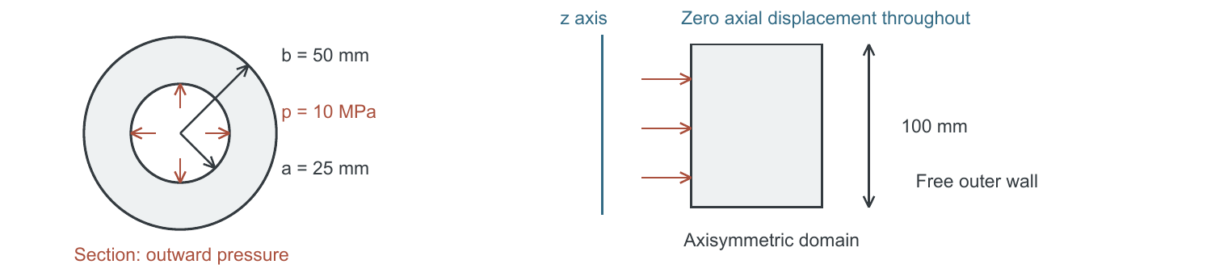

Problem conditions
Geometry | Inner radius a = 25 mm; outer radius b = 50 mm; length 100 mm
Material | E = 210 GPa; ν = 0.30; homogeneous isotropic linear elasticity
Load | Internal pressure p = 10 MPa; zero external pressure; no end-cap load
Assumptions | Axisymmetry; zero axial strain; axial displacement u_z = 0 throughout

Modelling prompt
Use AgentFEM to analyse a thick-walled cylinder: inner radius 25 mm, outer radius 50 mm, length 100 mm, Young’s modulus 210 GPa and Poisson’s ratio 0.3. Apply 10 MPa internal pressure, leave the outer wall radially free and apply no end-cap load. Use a linear-elastic axisymmetric model with zero axial displacement throughout. Report how far the inner wall expands outward (μm), plot radial displacement from the inner to the outer wall, and compare with Lamé’s analytical solution.

Tasks
1. Check the directions of internal pressure and radial displacement.
2. Increase the outer radius to 60 mm. Keep inner radius and pressure fixed; compare inner-wall displacement.
3. Calculate analytical displacements for both radii and explain the effect of wall thickness.

Comparison prompt
Increase the outer radius to 60 mm, keep everything else unchanged and run again. Compare the two inner-wall radial displacements, check them against Lamé’s solution and explain the effect of a thicker wall.
Submit the radial displacement profile with the analytical comparison and a table for both wall thicknesses.

Observations
Outer radius 50 mm: ______ μm 60 mm: ______ μm
Reduction in inner-wall displacement: ______ %

Exercise 3 Steady heat conduction in a plate
Distinguish prescribed-temperature and insulated boundaries, and temperature from heat flux.
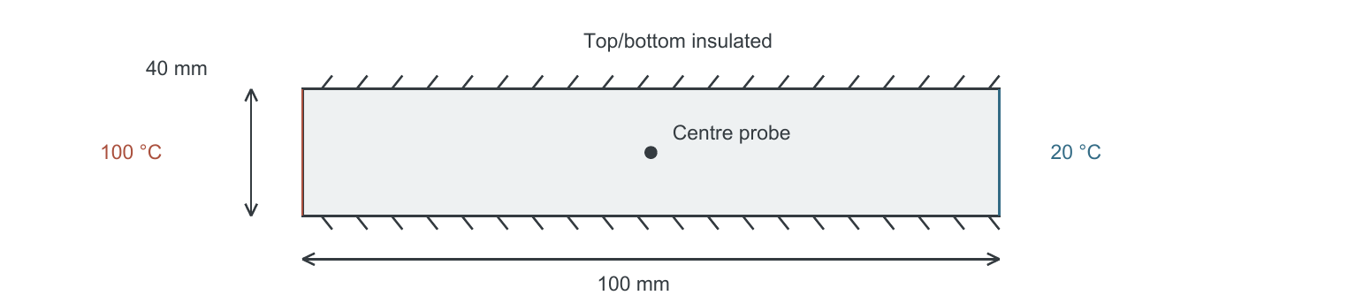

Problem conditions
Geometry and material | 100 mm × 40 mm; uniform k = 45 W/(m·K)
Temperatures | Left 100 °C; right 20 °C
Other conditions | Other boundaries insulated; no internal heat source; 2D steady conduction

Modelling prompt
Use AgentFEM for 2D steady-state heat conduction in a metal plate: length 100 mm, height 40 mm and uniform thermal conductivity 45 W/(m·K). Hold the left boundary at 100 °C and the right at 20 °C. Insulate all other boundaries and use no internal heat source. Show the temperature field, centre temperature (°C), temperature profile along the horizontal centreline and rightward heat flux density (W/m²).

Tasks
1. Record the centre temperature and describe the profile along the length.
2. Double conductivity to 90 W/(m·K), without changing the boundaries. Compare temperatures and heat flux.
3. Derive the temperature profile from the 1D steady heat equation and use Sixier’s law to calculate heat flux.

Comparison prompt
Increase thermal conductivity to 90 W/(m·K), keep everything else unchanged and run again. Compare the temperature fields and heat flux densities. Explain the result using Fourier’s law.
Submit the temperature field, a table of centre temperature and heat flux for both conductivities, and an analytical check.

Observations
k = 45: centre ______ °C; heat flux ______ W/m²
k = 90: centre ______ °C; heat flux ______ W/m²

Exercise 4 Transient heating of a plate
Read a temperature history, compare transient and steady states, and test time-step sensitivity.
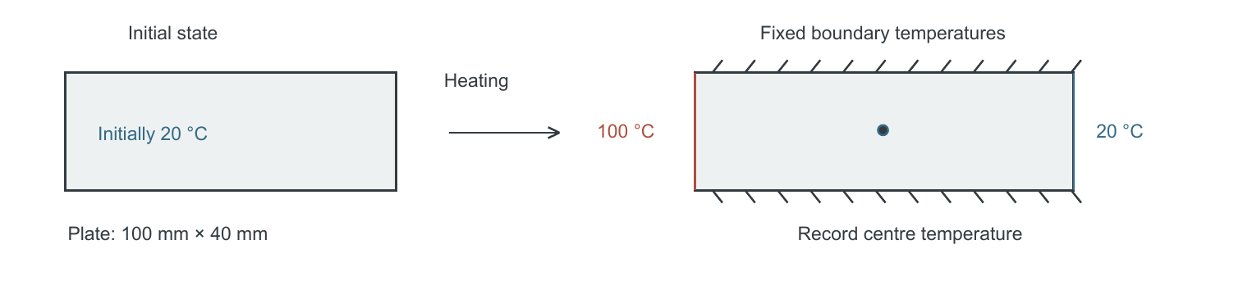

Problem conditions
Geometry | 100 mm × 40 mm plate
Material | k = 45 W/(m·K); ρ = 7800 kg/m³; c = 500 J/(kg·K), all constant
Initial and boundary conditions | Initially 20 °C throughout; for t > 0, left 100 °C and right 20 °C
Other conditions | Other boundaries insulated; no internal heat source
Time integration | To 600 s; backward Euler; initial time step Δt = 2 s

Modelling prompt
Use AgentFEM to simulate transient heating of a 2D metal plate: length 100 mm, height 40 mm and initial temperature 20 °C. Keep thermal conductivity 45 W/(m·K), density 7800 kg/m³ and specific heat capacity 500 J/(kg·K) constant. From the start of heating, hold the left boundary at 100 °C and the right at 20 °C. Insulate all other boundaries and use no internal heat source. Run to 600 s using backward Euler with a 2 s time step. Provide the centre-temperature curve and data table (°C). Save the temperature field every 10 s as a time series playable in ParaView.

Tasks
1. Plot centre temperature and record values at 60, 120, 300 and 600 s.
2. Repeat with a 1 s time step and the same mesh. Compare temperatures at shared sample times.
3. Compare with Exercise 3 and justify whether the plate is sufficiently close to steady state at 600 s.

Comparison prompt
Reduce the time step to 1 s, keep the mesh and all other conditions unchanged and run again. Overlay the two centre-temperature curves. Compare the maximum temperature difference at shared sample times and the difference at 600 s to assess whether the original time step is adequate.
Submit both temperature histories, the four-time table, time-series files and your time-step assessment.

Observations
60 s: ______ °C 120 s: ______ °C
300 s: ______ °C 600 s: ______ °C
Maximum difference between time steps: ______ °C

Exercise 5 Column response under compression
As compression increases, does sideways displacement remain proportional to the load? Plot the response and see what happens near Euler’s critical load.
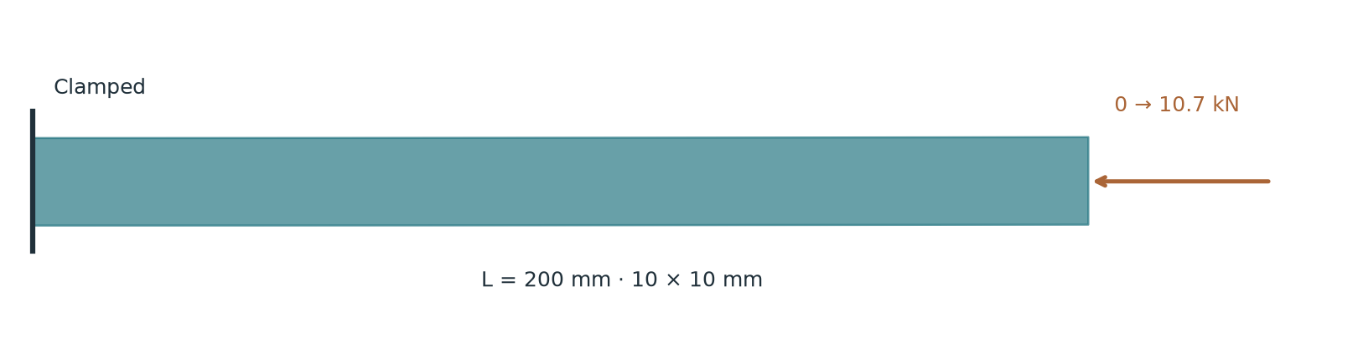
Requires AgentFEM with geometric nonlinearity and plane-stress StVK elasticity.

Modeling prompt
Use AgentFEM to compress a slender column gradually: length 200 mm, section 10×10 mm, E=210 GPa, Poisson’s ratio 0.3. Clamp the left end and apply uniform compression along the original axis at the right end; leave other boundaries free. Use a linear elastic material with geometric nonlinearity. Add the first buckling shape as an initial bow of amplitude 0.1 mm. Increase total force from 0 to 10.7 kN. Plot force against lateral tip displacement and compare with Euler’s critical load. Show several deformed shapes, explain in two or three sentences.

Follow-up prompt
Increase the initial bow from 0.1 to 0.2 mm, keeping other settings unchanged. Overlay the two load–lateral displacement curves and compare their deflections at the same load.

Observations
Euler critical load: ________ kN Lateral displacement at 9 kN: ________ mm
How does the curve change near the critical load? ________________
Submit one comparison plot, key values and a two- or three-sentence explanation.

Exercise 6 Tension of a re-entrant honeycomb
A solid plate usually narrows when stretched. A re-entrant honeycomb made of the same material can widen. Download and unzip the mesh pack, then give the folder to your AI assistant.
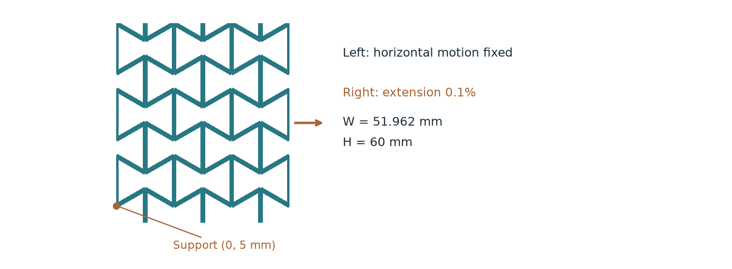
Download and unzip the pack; give the folder containing honeycomb.msh to the AI. Coordinates are in metres.
https://lab.haoming-luo.com/learn/files/honeycomb.zip

Modeling prompt
Use AgentFEM to import the attached honeycomb.msh without redrawing the geometry. Coordinates are in metres; width 51.9615 mm, height 60 mm. Boundary tags 11/12/13/14 mean left/right/bottom/top. Use small-strain linear elasticity in 2D plane stress, E=1 GPa and Poisson’s ratio 0.3; neglect gravity. Fix horizontal displacement on the left and impose a horizontal extension of 0.1% of the width on the right. Leave vertical motion free except at the lowest node on the left boundary (honeycomb: x=0, y=5 mm; solid plate: bottom-left corner). Use mean displacements on all four boundaries to calculate axial and transverse strains and apparent Poisson’s ratio. Compare with a solid plate of the same size, material and constraints. Show both deformed shapes side by side with their original outlines; magnify displacement 100 times and label the factor.

Follow-up prompt
Use these results to make a looping GIF showing the honeycomb and solid plate stretching together and returning to their original shapes. Keep the view and axis limits fixed, show the original outlines, and label displacement magnification ×100.

Observations
Honeycomb: axial strain ________ transverse strain ________ ratio ________
Solid plate ratio: ________ GIF file: ________________
Submit one comparison plot, key values and a two- or three-sentence explanation.

Reference answers 1
Complete your observations before checking. Use these values to verify magnitudes and trends; different meshes need not agree digit for digit.

1 Cantilever deflection
For a rectangular section and an Euler–Bernoulli cantilever:
I = bh³/12 = 6.667 × 10⁻⁹ m⁴; δ = FL³/(3EI).
Total force | Beam theory / mm | FE or linear scaling / mm
200 N | 0.381 | 0.383 (FE)
400 N | 0.762 | 0.766 (linear scaling)
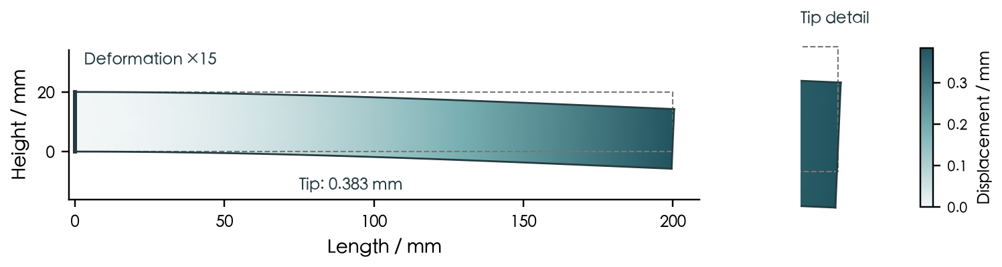
Figure 1. Beam displacement; dashed outline: original shape; deformation ×15.
Downward displacement is negative when y points upwards; the table reports its magnitude. The FE value is about 0.59% above beam theory. The 2D elasticity solution includes shear and end-restraint effects, whereas beam theory is approximate. Doubling the load gives a displacement ratio of 2 in linear elasticity.

2 Thick cylinder under internal pressure
For zero axial strain and zero external pressure, Lamé’s solution gives:
A = pa²/(b² − a²); B = pa²b²/(b² − a²).
u_{r}(r) = [(1 + ν)/E] [(1 − 2ν)Ar + B/r].
Outer radius | Inner displacement / μm | Source
50 mm | 2.270 | Analytical and baseline FE
60 mm | 2.003 | Analytical
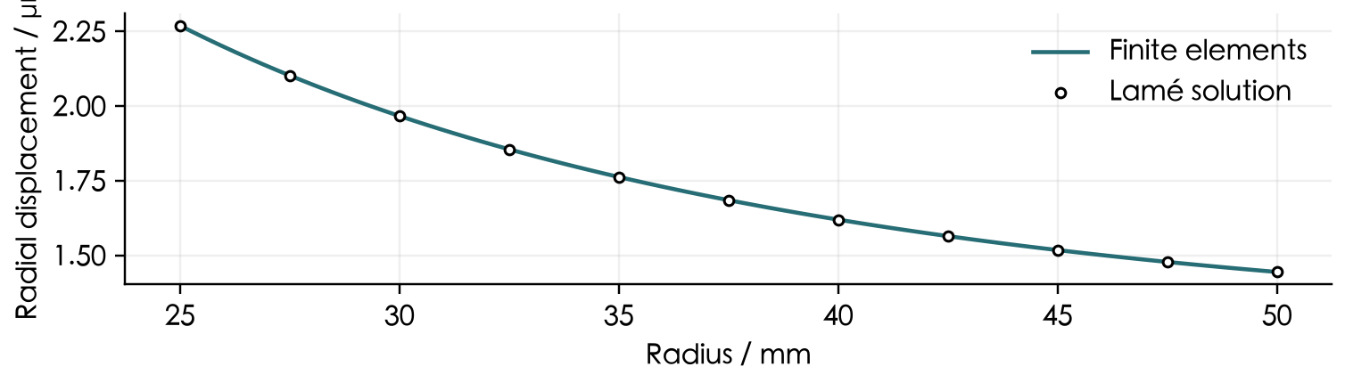
Figure 2. Radial displacement through the wall and Lamé’s solution.
Increasing the outer radius from 50 to 60 mm reduces inner-wall displacement by about 11.76%. The axial restraint is unchanged. Do not apply this displacement formula directly to a freely extending or end-capped cylinder.

Reference answers 2

3 Steady heat conduction in a plate
With uniform material, no internal source and insulated top and bottom boundaries, temperature depends only on x. Set L = 0.1 m, with x increasing to the right:
T(x) = 100 − 80x/L (°C); q_{x} = −k dT/dx = 80k/L.
Conductivity / W/(m·K) | Centre / °C | Heat flux / W/m²
45 | 60 | 36 000
90 | 60 | 72 000
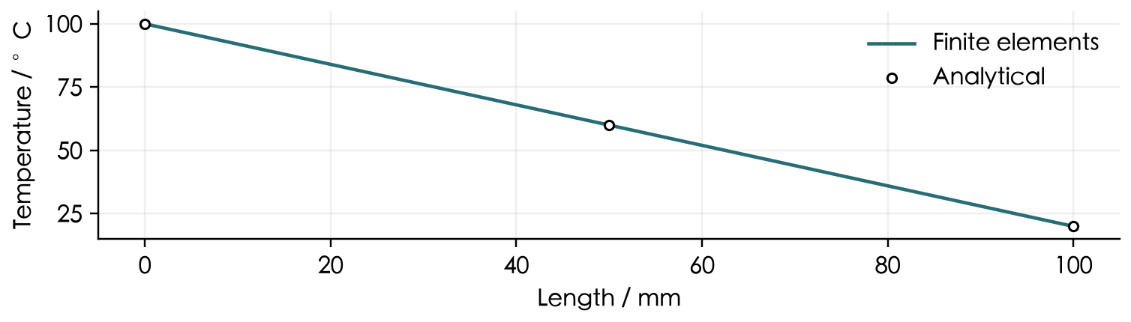
Figure 3. Temperature along the horizontal centreline.
At fixed end temperatures, changing uniform conductivity does not change this temperature profile, but it changes heat flux. Positive flux points to the right.

4 Transient heating of a plate
Thermal diffusivity α = k/(ρc) = 1.154 × 10⁻⁵ m²/s. The analytical centre temperature for t > 0 is:
T(L/2,t) = 60 − (160/π) Σ_{n=1}∞ [sin(nπ/2)/n] exp(−n²π²αt/L²).
Time / s | Δt = 2 s / °C | Δt = 1 s / °C | Analytical / °C
60 | 34.147 | 34.231 | 34.319
120 | 46.814 | 46.914 | 47.014
300 | 58.263 | 58.296 | 58.328
600 | 59.941 | 59.943 | 59.945
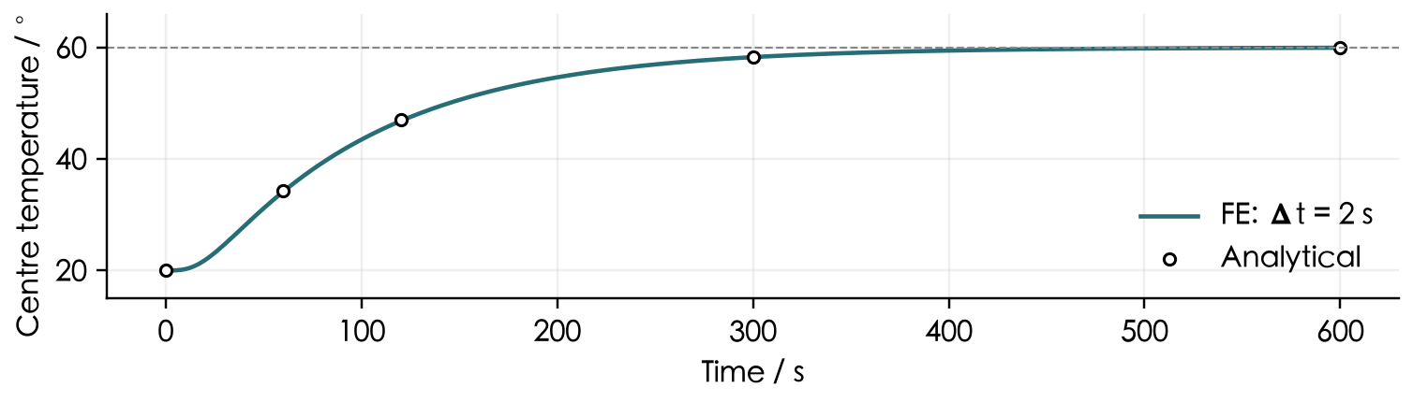
Figure 4. Centre temperature history; dashed line: steady state at 60 °C.
The maximum difference at shared sample times is 0.133 °C; at 600 s it is 0.0022 °C. Agreement at the endpoint alone is insufficient: check the whole history against the required accuracy.
Reference runs: AgentFEM 0.4.0.dev0 / DOLFINx 0.11.0. Beam: 80 × 8 quadratic elements; cylinder: 40 × 4 quadratic elements; heat: 80 × 16 linear elements. Backward Euler for transient heat; values converted to the displayed units.

Reference answers 3

5 Column buckling
I = bh³/12; P_{cr} = π²EI/(4L²).
Total force / kN | Mean tip lateral displacement / mm
6.0 | 0.125
9.0 | 0.505
10.7 | 11.953
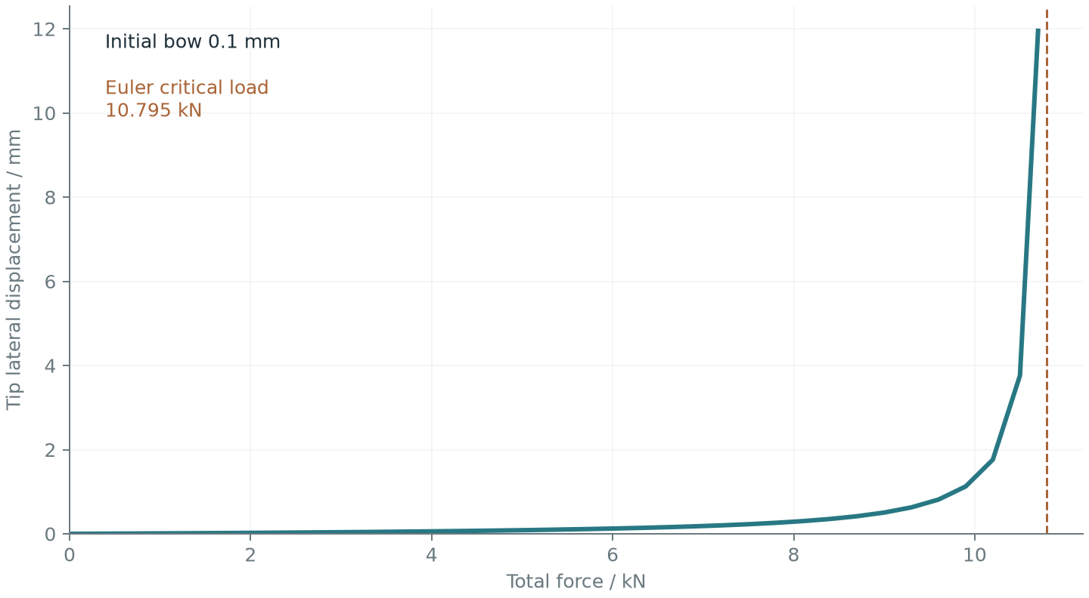
Euler gives 10.795 kN. Deflection is measured from the initial bowed shape and grows rapidly near this load. The imperfect response is not an ideal bifurcation; yielding is excluded.

6 Negative Poisson’s ratio
ν_{app} = −ε_{y}/ε_{x}.
Specimen | Axial strain | Transverse strain | Apparent ratio
Honeycomb | 0.001000 | 0.001303 | -1.3026
Solid plate | 0.001000 | -0.000300 | 0.3000
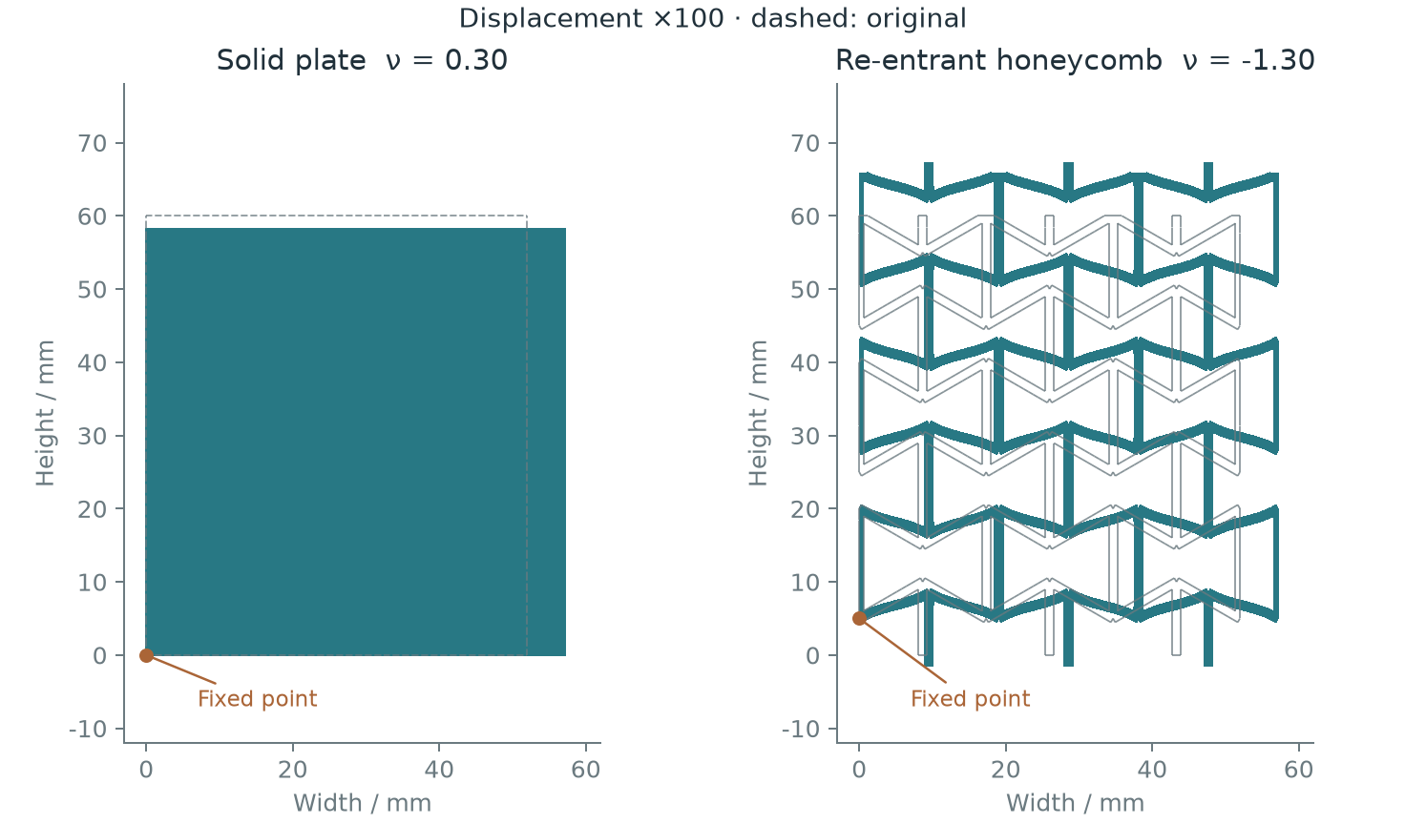
Figures and GIF: display ×100, actual extension 0.1%. The GIF interpolates linear results; it is not dynamics. Refinement gives −1.3062, a 0.28% change.

References
[1] Interactive web edition with copyable prompts and results. https://lab.haoming-luo.com/learn/en.html
[2] AgentFEM installation guide. https://github.com/haoming-luo/agentfem/blob/main/INSTALL.md
Acknowledgments: We thank Professor Meng Wang of Beijing Institute of Technology for first proposing the use of AI-native finite-element simulation in the classroom, and Renzi Bai of Northwestern Polytechnical University for completing the first validated AgentFEM installation on Windows and contributing to this handout.

